QUADRATIC GRAPHS
OCR Thursday 07 November 2019- Morning (Non-Calculator) Foundation Tier
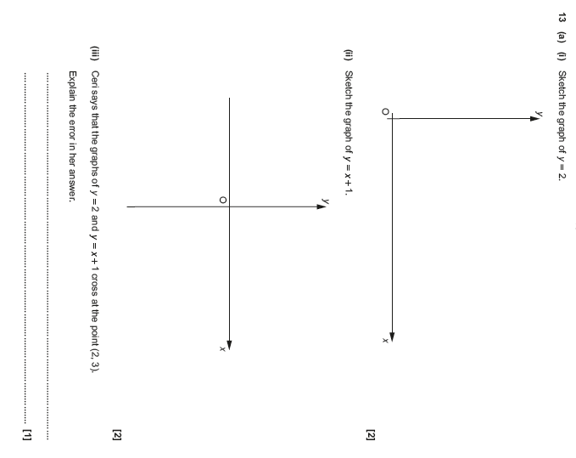

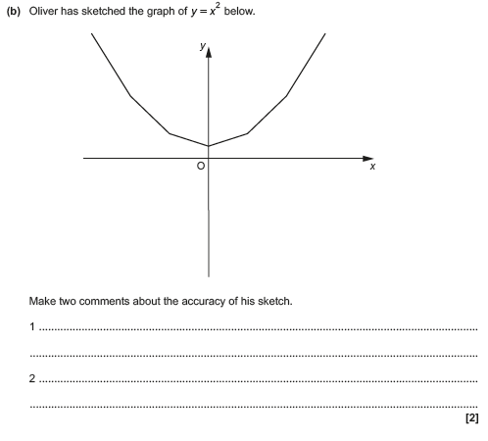

OCR Thursday 2 November 2017– Morning (Calculator) Foundation Tier

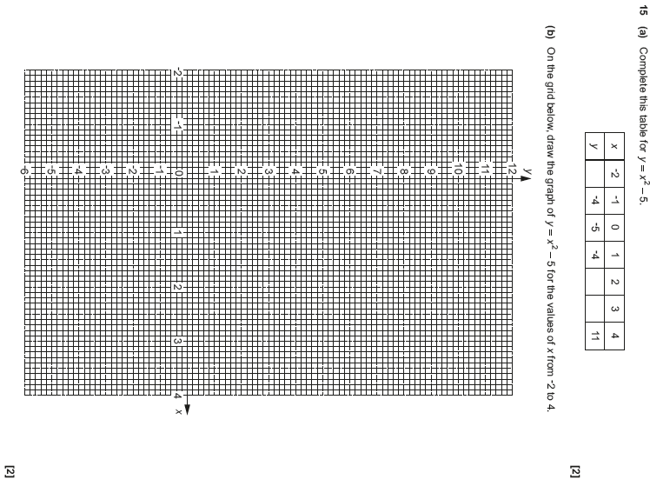

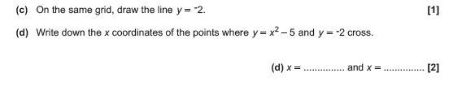

AQA Monday 12 November 2018 – Morning (Calculator) Foundation Tier

